**Creation Table:**

1. Customer:

create table Customer

(customer_id int(1),first_name varchar(10),last_name varchar(15),email varchar(25),address varchar(30),city varchar(15),state varchar(5),zipcode int);

insert into Customer

values(1,'George','Washington','gwashington@usa.gov','3200 Mt Vernon Hwy','Mount Vernon','VA',22121);

insert into Customer

values(2,'John','Adams','jadams@usa.gov','1250 Hancock St','Quincy','MA',02169);

insert into Customer

values(3,'Thomas','Jefferson','tjefferson@usa.gov','931 Thomas Jefferson Pkwy','Charlottesville','VA',22902);

insert into Customer

values(4,'James','Madison','jmadison@usa.gov','11350 Constitution Hwy','Orange','VA',22960);

insert into Customer

values(5,'James','Monroe','jmonroe@usa.gov','2050 James Monroe Parkway','Charlottesville','VA',22902);

Select * from Customer;

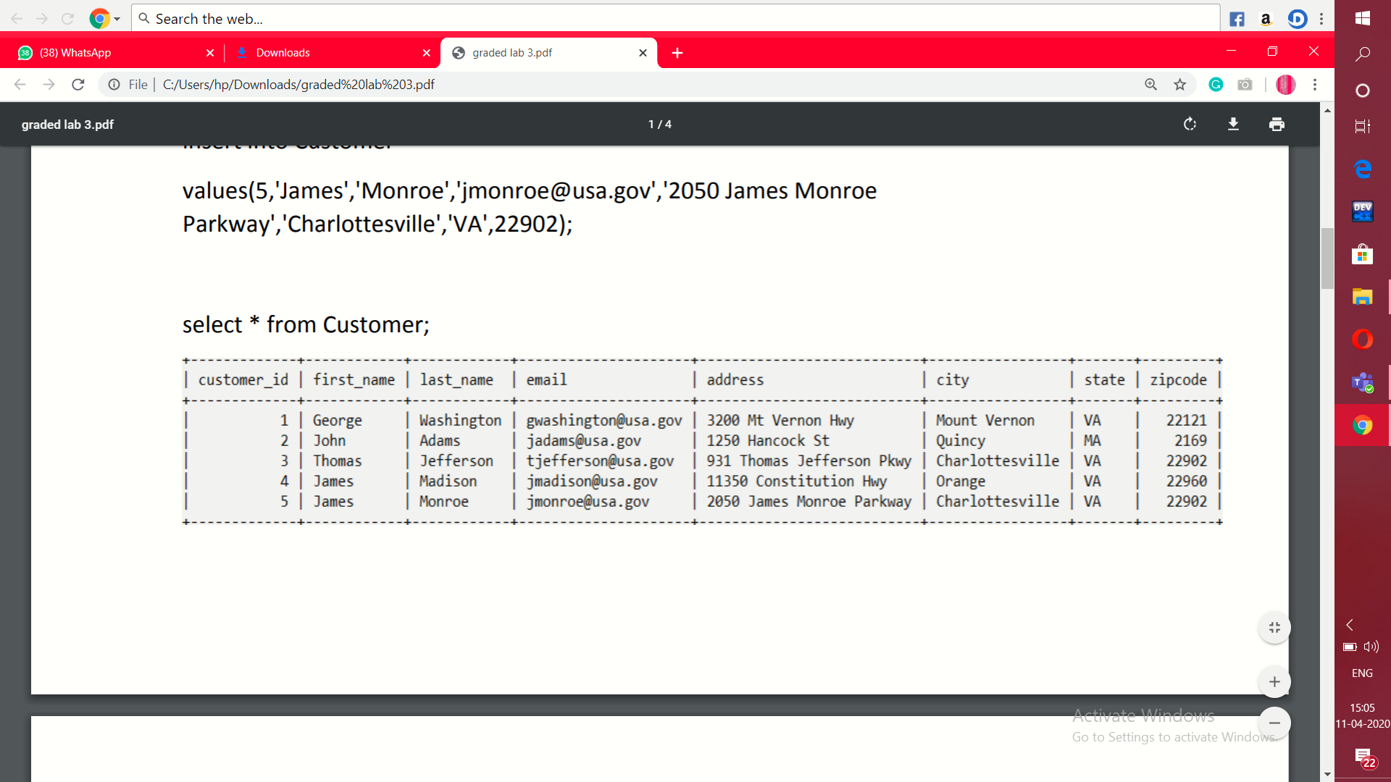

**Order:**

create table order

(order_id int(1),order_date date,amount varchar(10),customer_id int);

insert into order

values(1,'1776/07/04','$234.56',1);

insert into order

values(2,'1760/03/14','$78.50',3);

insert into order

values(3,'1784/05/23','$124.00',2);

insert into order

values(4,'1790/09/03','$65.50',3);

insert into order

values(5,'1795/07/21','$25.50',10);

insert into order

values(6,'1787/11/27','$14.40',9);

Select * from Order;

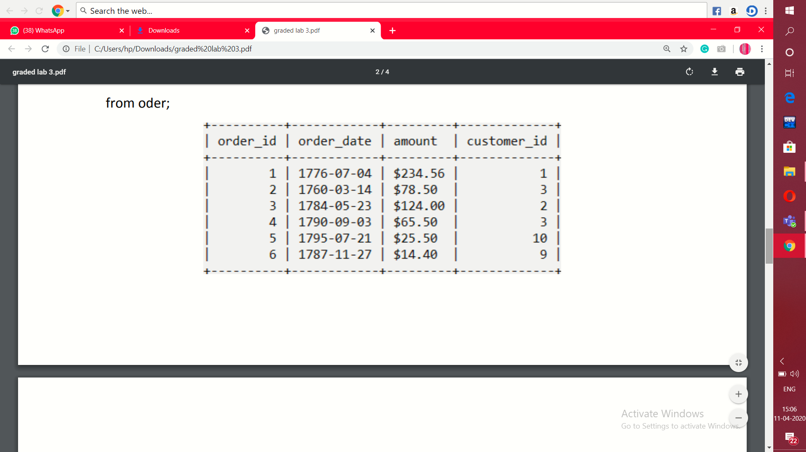

**Queries:**

1. **List of those customers who placed an order and the details of the order they placed and table should not display customer who have not placed any order.**

select *

from Customer

natural join Order;

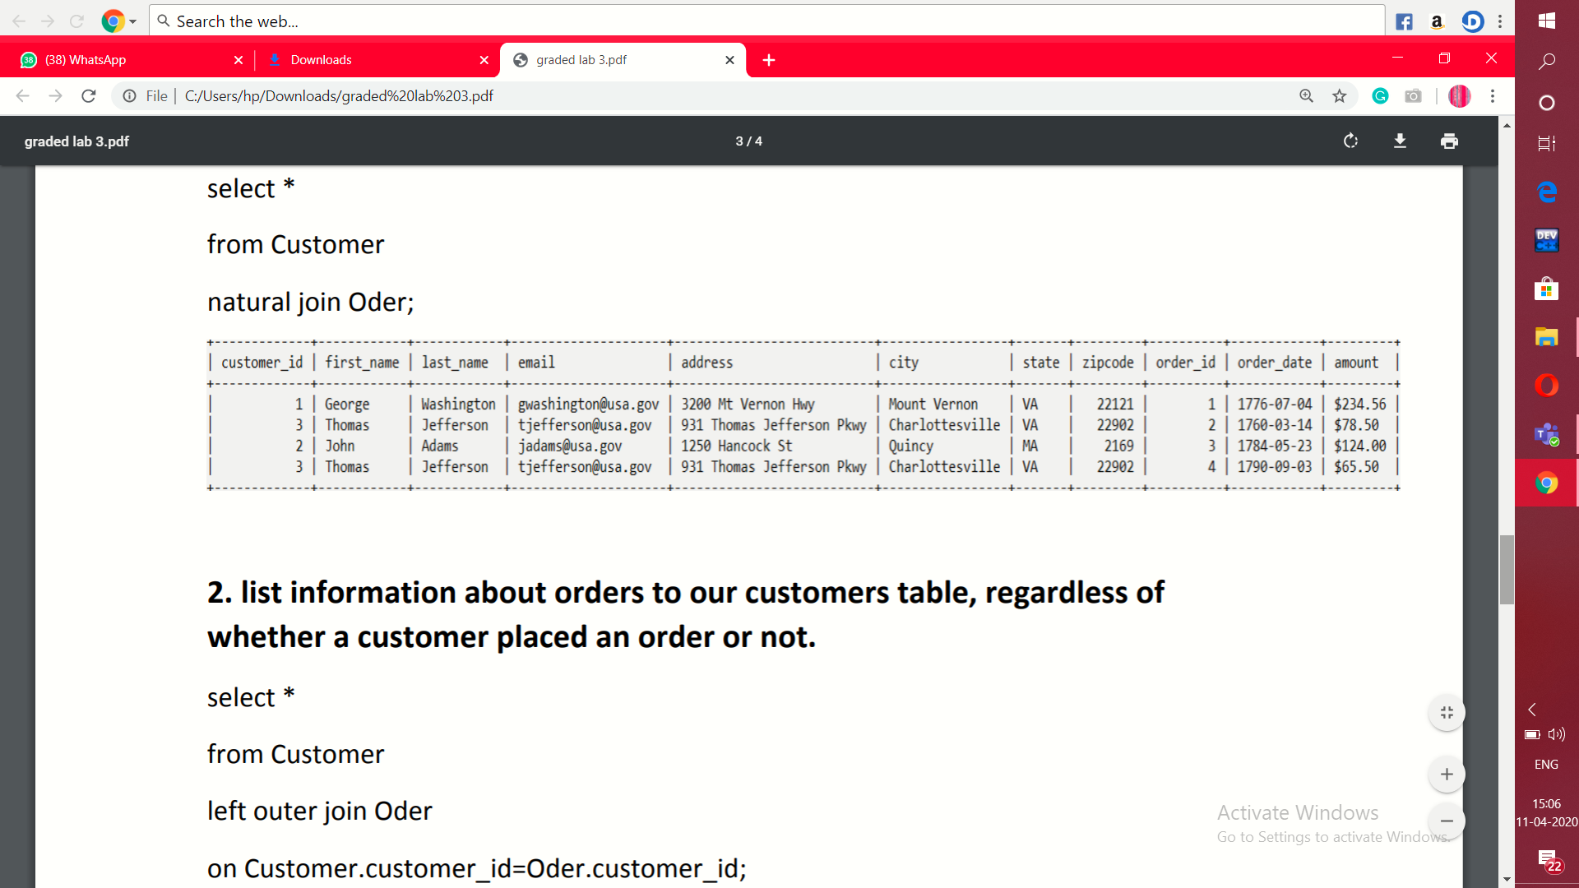

1. **List information about orders to our customers table, regardless of whether a customer placed an order or not.**

select * from Customer

left outer join Oder

on Customer.customer_id=Oder.customer_id;

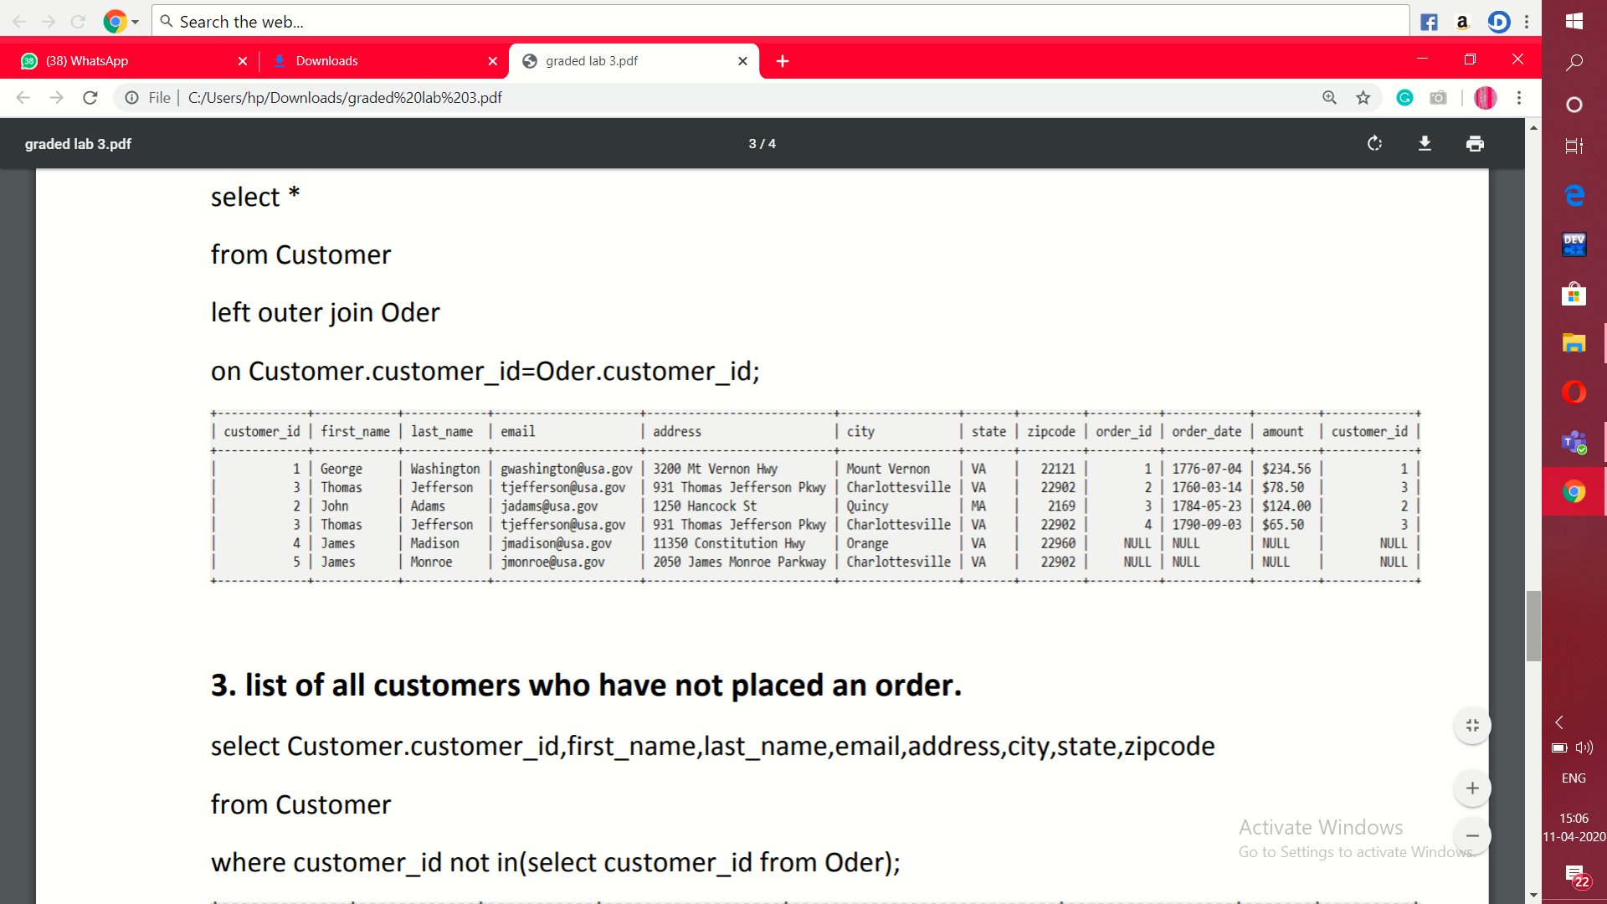

1. **List of all customers who have not placed an order.**

select Customer.customer_id,first_name,last_name,email,address,city,state,zipcode from Customer

where customer_id not in(select customer_id from Oder);

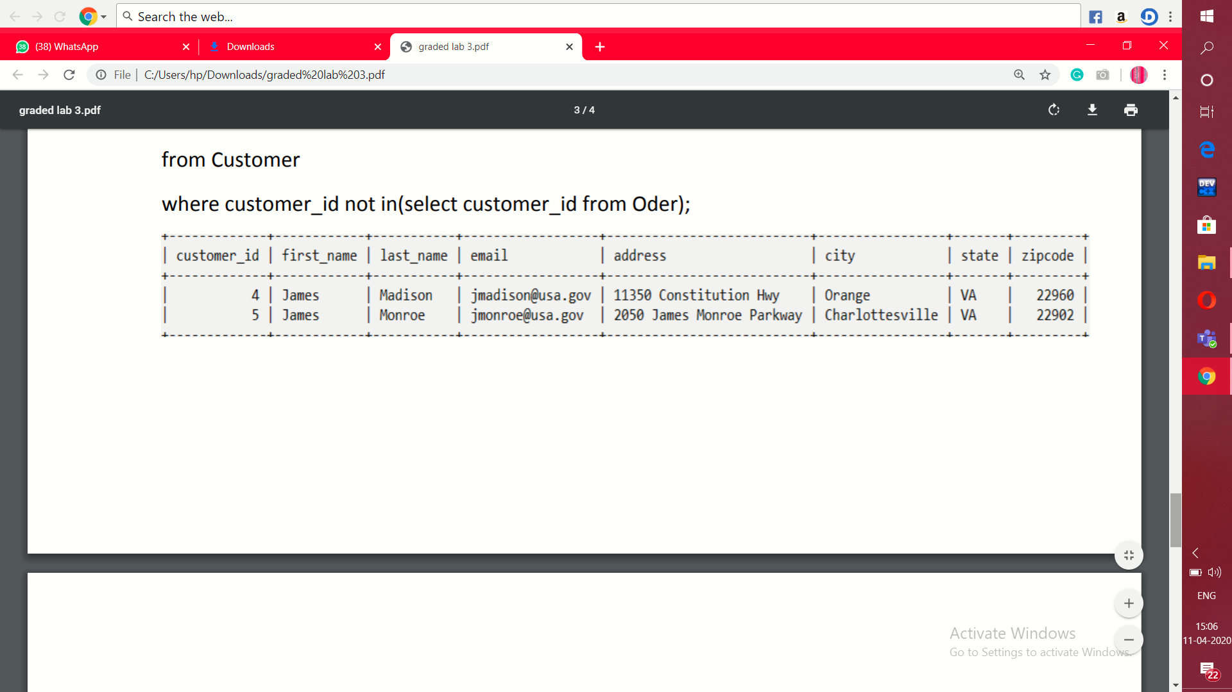

1. **Display total sum for each customer oders.**

select Customer.customer_id,count(Oder.customer_id)

from Customer

left outer join Oder

on Customer.customer_id=Oder.customer_id

group by Customer.customer_id;

